Life@SJRPS-Rajajinagar

Retain the content. Pictures are in Picture folder

News & Updates
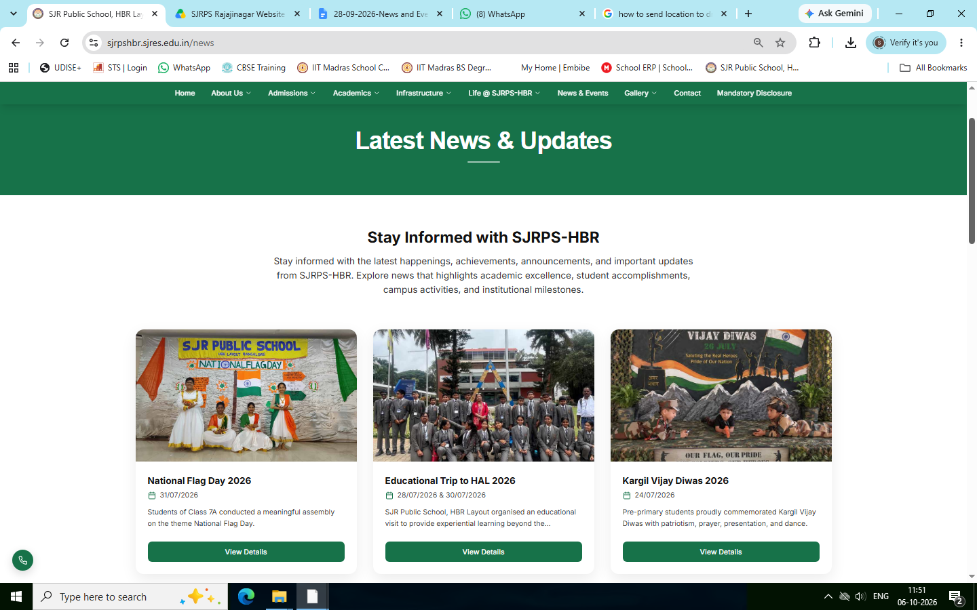
Changes Required

Photos are uploaded in google drive along with content. (Photos>Events)

